Case 6-Afr-*DR Congo*-helmet mask-***Bwoom***-wood, leather, shell-19th c

***Note:******The Democratic Republic of the Congo*** *(DR Congo) has been known as, in chronological order, the Congo Free State, Belgian Congo, the Republic of Congo-Léopoldville, the DR Congo and the Republic of Zaire, before returning to its current name the DR Congo*

***Note: The Kongo people*** *(singular: Mukongo, pl. Bakongo) speak Kikongo, a Bantu language, who have lived along the Atlantic coast of Central Africa, in a region that, by the 15th century, was a centralized and well-organized Kongo Kingdom but is now a part of three countries: the DR Congo, the Republic of the Congo and Angola.*

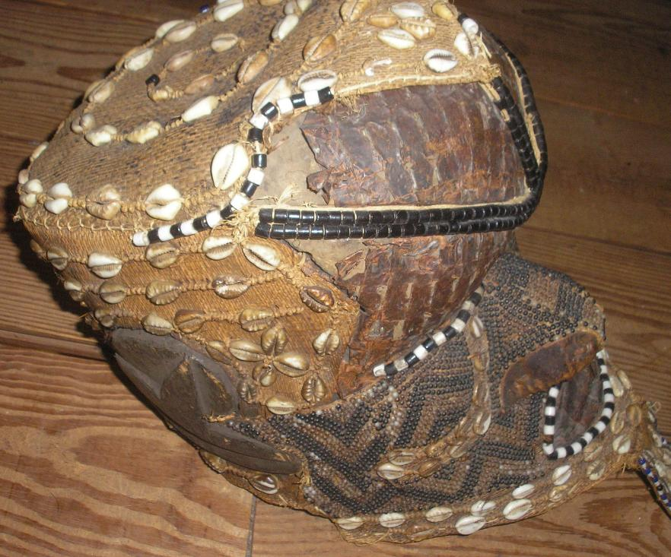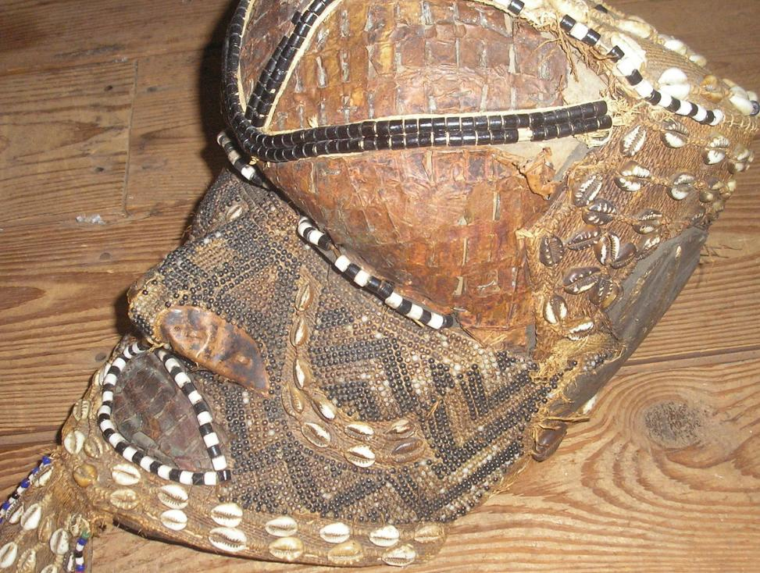

Fiigs. 1-2. Congo DR-helmet mask-***Bwoom***-the Pygmy-wood-19th c

**Case no.: 6**

**Accession Number:**

**Formal Label:** Congo DR-helmet mask-***Bwoom***-the Pygmy-wood-19th c

**Display Description:**

This Bwoom helmet mask of the Kuba-Bushongo-Bushoong or Pygmies Democratic Republic of Congo, Atlantika Collection.

This large, proportioned, hollow wooden mask probably dates to the early twentieth century. The perimeter, temples, pate and back are decorated with beads and cowrie shells (used in the area as currency). A pendant “beard” has cowry shells surrounded by beads. The broad face has an incised zigzag motif similar to the geometric keloid scars that are applied to the Kuba body and which are replicated in textile designs (Cornet 1982:266; see Fig. 3). In this example, the carved wood understructure is covered with copper sheeting that is extended by a beard made of hide and accented throughout by beadwork. Beads also embellish the contours of both the eyes and the mouth. A series of bead bands crosses the surface of the face, one from the crown of the head to the tip of the nose and another from one side of the head to the other, bisecting the eyes.The cheeks are outlined with dual bands of cowry shells, and the crown is covered with animal skin surmounted by three bands of two strand ancient beads.

The Kuba have three royal mask types: 1) ***Mwaash a Mbooy***, representing Woot and the king; 2) the wooden face mask, ***Ngady Mwaash a Mbooy***, the incestuous sister-wife of Woot; and 3) the wooden helmet mask, ***Bwoom***, the Pygmy, also the challenging brother and the common man. These characters appear in a variety of contexts including public ceremonies, rites involving the king, and initiations. Although their dances are generally solo, together the three royal masqueraders re-enact Kuba myths of origin (Cornet 1982: 254, 256; Roy 1979:170).

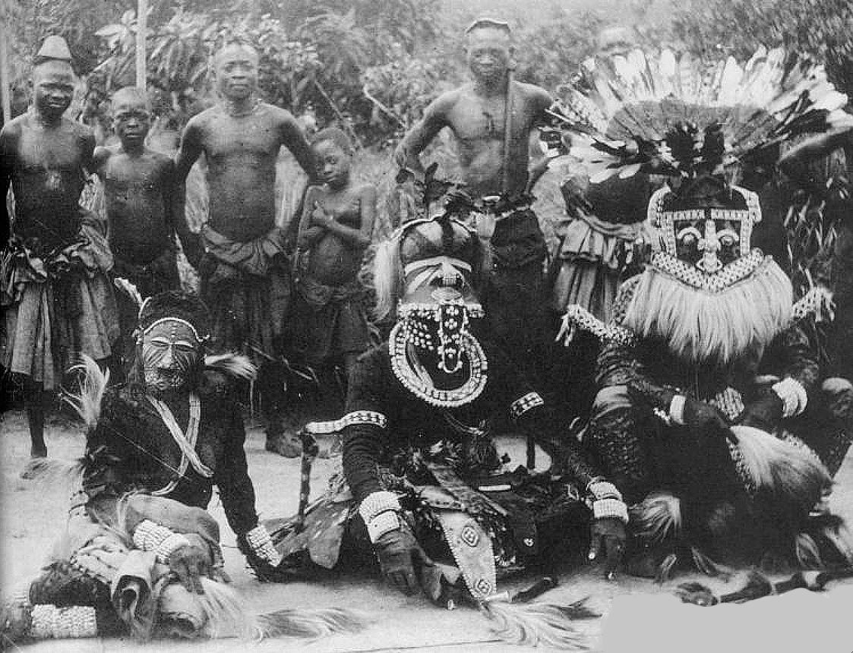

Fig. 3. Kuba masqueraders, Nesheng, southern Kasai River, 1909. Royal Kuba Masqueraders, Nsheng, Kasai, Congo, 1909 (after the Library of the University of Michigan, Image 344206, http://quod.lib.umich.edu/h/hart/x-344206/03d100403). Front, center,***Bwoom*** masquerader, hydrocephalic (large-headed) aboriginal pygmy symbolizing profound local knowledge of the forest and its medical riches. Front-center, right: ***Mwaash aMbooy***, representing Woot, the founding ancestor of the Kuba. Front–center left: ***Ngady Mwaash aMbooy***, the incestuous sister-wife of Woot.  
  
The *Bwoom* mask proper dates to the early eighteenth century. A royal mask attributed to King Miko mi Mbul dates to ca. 1800-ca. 1835 (Cornet 1975: no. 63, p. 89). An eighteenth-century song for the son of King Kot aNce refers to the first recorded instance of adorning *Bwoom* masks with cowries and beads., implying that earlier masks were devoid of these accoutrements at signified wealth. Many variations of the mask evolved perhaps from prototypes (Vansina 1978: 216).

**LC Classification:** NB1099.C6

**Date or Time Horizon:** 19th c

**Geographical Area:** DR Congo

**Map:**

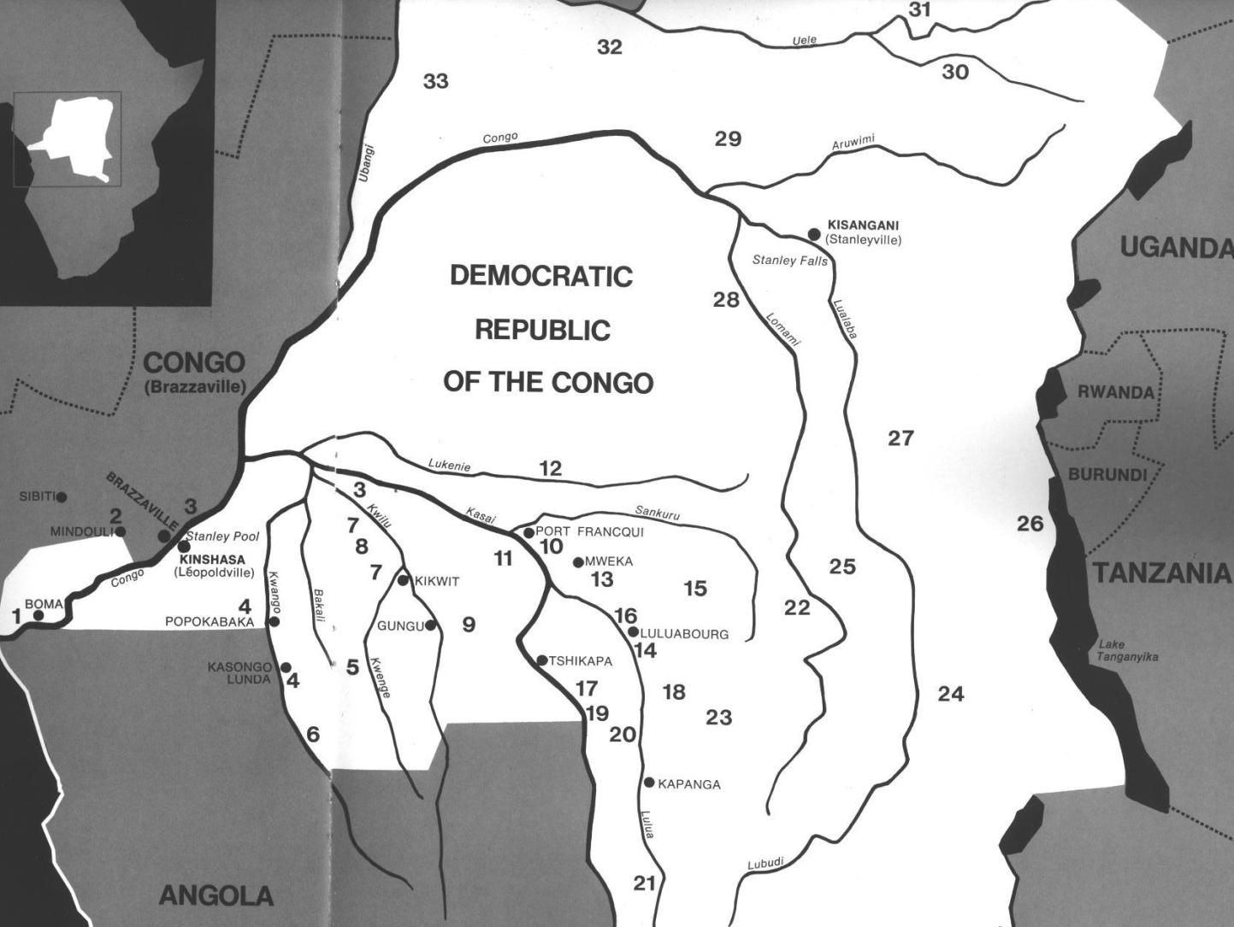

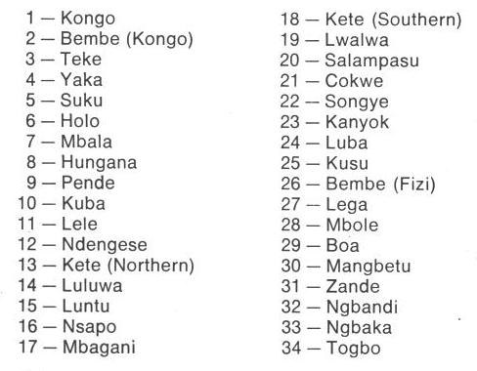

Fig. 1. Map of Kongo Cultures, West Central Africa. After Walker Art Center 1967.

**GPS coordinates:**

**Cultural Affiliation:** Kongo peoples

**Media:** Wood, hammered copper, raffia fiber, animal skin, cloth, beads, cowrie shells.

**Dimensions:**

**Weight:**

**Condition: original**

**Provenance:**

**Discussion:**

The *Bwoom* mask has three aspects: 1) as a Pygmy, 2) as a challenging brother, and 3) as a common man:

1) The *Bwoom* as a Pygmy. The Pygmies are forest-dwelling, hunter-gatherers and know this seemingly impenetrable landscape intimately. The ancient idea that a society's landscape is its own because its ancestors are buried there is central to Pygmy cosmology. The Kuba recognized this ancient idea. When they migrated into Pygmy forests they realized that their hope of a successful life in this landscape was to ally themselves with the Pygmies and learn the Pygmy lore of the ancient ancestral forest spirits (cf. Ehret 2002:50; Schadeberg 1999). Appropriately, *Bwoom* is the first spirit seen as an apotheosis by *nkan* initiates.

2) The *Bwoom* as the challenging brother. This aspect of the *Bwoom* invokes a ritual reenactment of the struggle for social power of the challenging brother who seeks both the throne of his brother, *Mwaash A Mboy*, and the king's wife, *Ngaady A Mwaash*. *Bwoom*, therefore, supports the challenge of authority.

3) The *Bwoom* as the common man. This role of the *Bwoom* fostered the respect of the individual's rights and the need for consensus among commoners as necessary checks and balances to offset royal authority.

Two traditions trace *Bwoom*'s origin to the problem of royal succession: King Miko mi-Mbul killed the children of his predecessor so that he could succeed to the throne. However, he subsequently went mad. (Even today the issue of royal succession is critical to West and Central African peoples as the slaughter at Yendi in northwestern Ghana illustrates in 2004 when the king of Yendi murdered the offspring of his rival in Tamale.) Although King Miko mi-Mbul eventually regained sanity, he would lapse into madness each time he wore the *Mwaash a Mbooy*, the sole royal mask.

A Pygmy, an outsider who, by his small stature, was considered even less challenge than a Kuba commoner, offered the king a *Bwoom* mask as a gift, and Miko accepted it. Its effects were profound, yet covert. With the *Bwoom* mask the king became like those whom he had previously despised. He learned empathy. Another version is that King Miko mi-Mbul, who was known as a great dancer, was seduced by the Pygmy’s mask because the King Miko mi-Mbul danced with it so well in the rites, despite its overtly humble character.

The king was able to enter the soul of the commoners and therefore perceive their innermost desires for a just rule. In order to soften the critique of royal malfeasance, in both versions the King is reputed to have made alterations to the mask that justified its inclusion in the royal repertoire (Cornet 1982:269). These accounts reify the need for royal power to be circumscribed (literally) by commoners "of low standing scarcely worthy of being embodied by the king" (Cornet 1975: 89).

The defiant performance of *Bwoom* opposes the regal *Mwaash a Mbooy*. The two act out a competition for one female in the royal mask trio, *Ngady mwaash aMbooy* (Cornet 1982:255). Mwaash aM-booy's dance is calm, stately and without passion, while *Bwoom* acts with pride and passion (Cornet 1982:255). Materially, the masks are easily differentiated by material, for *Bwoom* is carved from a single piece of wood by male artisans and *Mwaash a Mbooy* is woven by women as a textile. Here a tension and quasi-contradiction is implicit: commoner men manufacture the mask of commoners and women, ostensibly the consorts of the king, manufacture the mask of royalty. *Bwoom* appears apotropaically on the *nkan* or "initiation fence" of the Kuba, prohibiting entrance to all not in the rite (Vansina 1955:150-151). *Bwoom* does not appear at funerals and is never interred with the king or other dignitaries because it is the spirit of the living commoners not of the king (Cornet 1982:270). The costume is similar to that of *Mwaash a Mbooy*: heavy with profuse layers of raffia-cloth, bead and cowry decoration, leopard skins, anklets, armlets, and fresh leaves. Eagle feathers or other prestigious media are added to the crown of the head when the mask is danced.

**References:**

Adams, Monni. 1988. 8th century Kuba king figures, *African Art* 21(3): 32-38, 88.

Belepe, Bope. 1974. *Etude socio-morphologique des masques Bwoom des Kuba: Memoire de licence en histoire.* Lubumbashi: Université Nationale du Zaire.

Belepe, Bope. 1981. Les oeuvres plastiques Africaines comme documents d'histoire: Le cas des statues Royales Ndop des Kuba du Zaire, *Africa­Tervuren* 25(1): 9-17.

Binkley, D. 1987. Avatar of power: Southern Kuba masquerade figures in funerary context, *Africa* 57 (1).

Binkley, D. 1990. Masks, space and gender in southern Kuba initiation ritual, *Iowa Studies in Art.* Vol. 3, *Art and Initiation in Zaire.* Iowa City: The University of Iowa.

Brett-Smith, Sarah. 1983. “The Doyle Collection of African Art,” *Record of the Art Museum, Princeton University*, 42(2): 2+8-34.

Kuba du Zaire, Africa­ Tervuren 27(1): 9-17.

Binkley, D. 1987. Avatar of power: Southern Kuba masquerade figures in funerary context, *Africa* 57 (1).

Binkley, D. 1990. Masks, space and gender in southern Kuba initiation ritual, *Iowa Studies in Art.* Vol. 3, *Art and Initiation in Zaire.* Iowa City: The University of Iowa.

Claerhout, A. 1976. Two Kuba wrought-iron statuettes, *African Art* IX (4): 60-64.

Cornet, J. 1972. *Art de l'Afrique Noire au pays du fleuve Zaire*. Brussels: Arcade.

Cornet, J. 1975. *Art from Zaire: 100 Masterworks from the National Collection.* New York: African-American Institute.

Cornet, J. 1982. *Art royal Kuba.* Milan: Sipiel.

Ehret, Christopher. 2002. *The civilizations of Africa: a history to 1800*. Charlottesville: Virginia: University of Virginia Press.

Forbath, Peter. 1977. *The River Congo*. Boston: Houghton Mifflin.

Laman, Karl. 1953. *The Kongo*. 4. vols. Stockholm: Victor Pettersons.

MacGaffey, Wyatt. 1986. *Religion and society in central Africa: the Bakongo of Lower Zaire*. Chicago: University of Chicago Press.

MacGaffey, Wyatt. 1988. “Complexity, astonishment and power: the visual vocabulary of Kongo minkisi,” *Journal of African Studies*, (14:2), 188-203.

Martinez-Ruiz, Barbaro. 2013. *Kongo Graphic Writing and other Narratives of the Sign*. Philadelphia: Temple University Press.

Rosenwald, J. B. 1974. “Kuba king figure,” *African Art,* VII (3).

Schadeberg, Thilo. 1999. “Batwa: the Bantu name for the invisible people.” In *Challenging Elusiveness: Central-African Hunter Gatherers in a Multidisciplinary perspective*, ed. K. Beibrouck, S. Elders, and G. Rossel. Leiden: CNWS, 21-39.

Thompson, Robert Farris. 1978. “The Grand Detroit N’kondi,” *Bulletin of the Detroit Institute of Arts* 56 :4, 206-217.

Torday, E. and T. A. Joyce. 1911. « Notes ethno­graphiques sur les peuples communement appeles Bakuba, ainsi que sur les peuplades apparentees, les Bushoongo. » In *Annales du Musee Royal du Congo Belge, Ethnographie et Anthropologic.,* serie III, tome II, fasc. 1. Brussels: Tervuren.

Vansina, Jan. 1955 “Initiation Rituals of the Bushong,” *Africa* 25(2): 138-153.

Vansina, Jan. 1964. *Le royaume kuba.* Tervuren: Musée royal de l'Afrique centrale.

Vansina, Jan. 1978. *The children of Woot. A history of the Kuba peoples.* Madison: University of Wisconsin Press/Dawson.

Vansina, Jan. 1984. *Art History in Africa.* London: Longman.

Van Wing, Joseph Hubert Leopold. 1941. *Études Bakongo*. II. *Religion et magie*. Institut royal colonial belge. Section des sciences morales et politiques. Mémoires, collection in-8°, t. IX, fasc. 1. Brussels: Desclée de Brouwer.

Van Wing, Joseph Hubert Leopold. 1959. *Études Bakongo.* Brussels: Desclée de Brouwer.

Walker Art Center. 1967. *Art of the Congo*. Minneapolis: Walker Art Center.



Fig. 5. Kuba woman with a geometric textile design similar to the zig-zag keloid scars of the Pygmy (after www.ezakwantu.com.)



Fig. 5. Kuba woman with a geometric textile design similar to the zig-zag keloid scars of the Pygmy (after www.ezakwantu.com.)